The Community Health Improvement Plan (CHIP) is a living document developed in response to the top health priorities identified in the Community Health Assessment (CHA). It serves as a five-year roadmap for the Mower County Community Health Board and its partners to work strategically toward addressing these priorities and reducing the barriers that contribute to them.
The CHIP is created collaboratively and reflects the voices and perspectives of those who live and work in Mower County. While the document is developed by the community health board, its foundation is built on community input and shared vision. As noted by the Minnesota Department of Health -the CHIP is not just written for the community—it is written by the community (Minnesota Department of Health, 2023).
We would like to thank everyone who was involved in the planning and development of our 2025-2030 CHIP. Every voice, story, insight, and lived experience that was shared drove this work to what it is today – without all of you, and your dedication to make a healthier and stronger tomorrow, this work could not have been possible.
To read the full report, please scan the QR code below or click HERE.
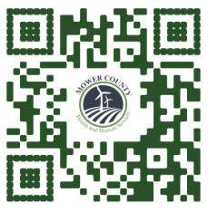
All data inquiries or questions regarding the material in either the CHA or CHIP can be made to Mower County Health and Human Services at (507) – 437-9701.

