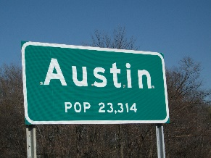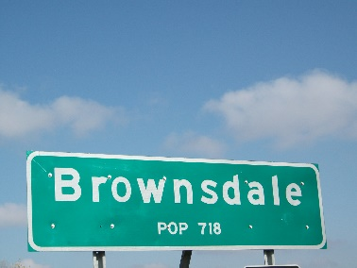

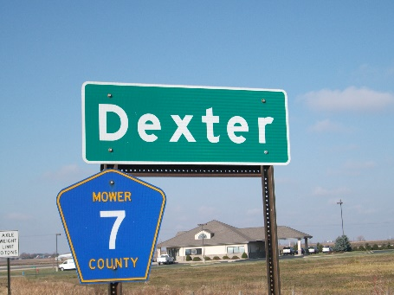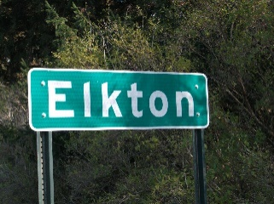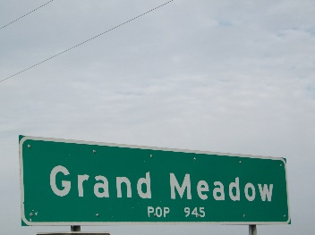

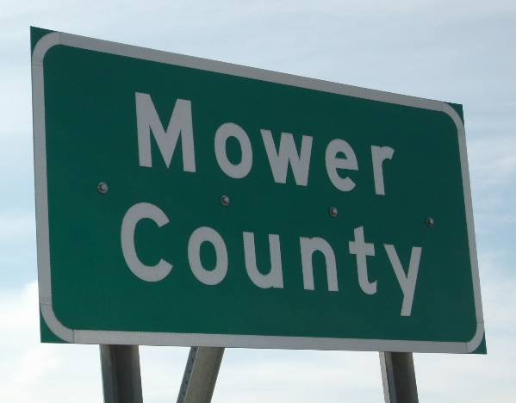
Mower County
Community Health Assessment and Improvement Plan

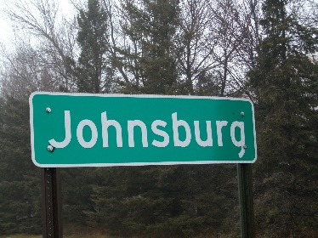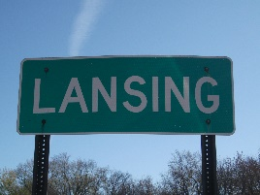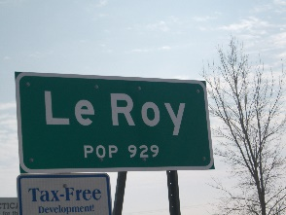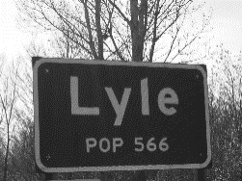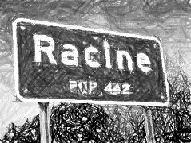
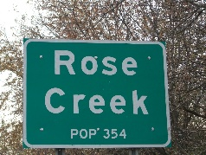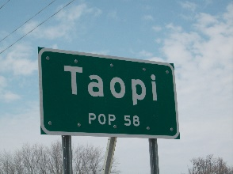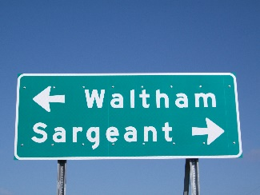

A collaborative strategy to improve
the health of Mower County.



December 2014

Table of Contents

Introduction………………...…………………………………..……...page 3

Community Stakeholders…………………………………………….page 4-5

Value Statement | Key Principles…………………………………...page 6

Demographics………………………………………………………...page 7-8

Community Health Assessment Process…………………………..page 9-10

Community-Driven Strategies & Planning | Top Three Priorities...page 10-11

Opportunity One: Increasing Nutrition & Active Living…………...page 11-13

Opportunity Two: Increasing Mental Health.…………………….page 14-15

Opportunity Three: Improving Access to Healthcare……………….page 16



Dear Residents of Mower County,

Improving health across all communities is essential to enhancing the quality of life for Mower County residents as well as supporting the area’s future social and economic well-being. Over the past year and one half Mower County Community Health Services has worked to complete a community health assessment and improvement planning process. I am so grateful to the many community stakeholders representing Mower County communities, schools, businesses, Mayo Clinic Health Systems - Austin, cultural leaders, and individuals that lent their time and talents to inform the document you have before you. It is with great pleasure that I introduce to you the Mower County Community Health Assessment and Improvement Plan 2014.

The Community Health Assessment and Improvement Plan illustrates the power of community driven efforts and the willingness to use and expand on existing strengths to improve the health of all Mower County citizens. We have come to understand that empowering all citizens to be a part of the solution builds on the investment of health for all. This document outlines what happens when citizens come together for the greater good to build on the foundations we have in place and plant new seeds of growth in ways we perhaps never thought of before.

This is a living document and with the help of our partners, the plan will be implemented over the next five years. Throughout the document you will read about the good work of citizens collaborating to create environments that foster new ideas and potential growth in the advancement of health for all. We commit to looking at outcomes to evaluate and improve the planning process. There is no doubt that there will be challenges, but with those challenges comes great opportunity. I encourage all Mower County citizens to get involved and contribute to this effort as we seek to improve the overall health of Mower County.

Sincerely,

Lisa Kocer, BSN, RN, PHN
Director, Community Health Services Administrator
Mower County Health and Human Services


Community Stakeholders

Mower County Community Health Board Members

Commissioner Tim Gabrielson – 1st District
Commissioner Polly Glynn – 2nd District
Commissioner Jerry Reinartz – 3rd District
Commissioner Tony Bennett – 4th District
Commissioner Mike Ankeny – 5th District

Mower County Community Health Services Advisory Committee Members

Dr. Vijay Chawla Medical Services Medical Consultant/ Mayo Clinic Health System
Mary Kunert Consumer Homemaker
Cheri May Licensed Nurse Retired Long Term Care
Dr. Peter Green Dental Health Dr. Elrod, Green, and Hyland
Sara Schafer Director Mower County Senior Center
Miguel Garate Advocate Riverland Community College
Jeff Sampson Administration Southland and Leroy Public Schools
Jeff Baldus Business Austin Area Foundation
Dr. James Shaffer Medical Services Quick Care Clinic
Jeff Goeldi Emergency Medical EMS
Dr. Gene Muchow Consumer Former Mower County Medical Consultant
Steve King Council Member Austin City Council
Polly Glynn Commissioner Mower County
Jerry Reinartz Commissioner Mower County

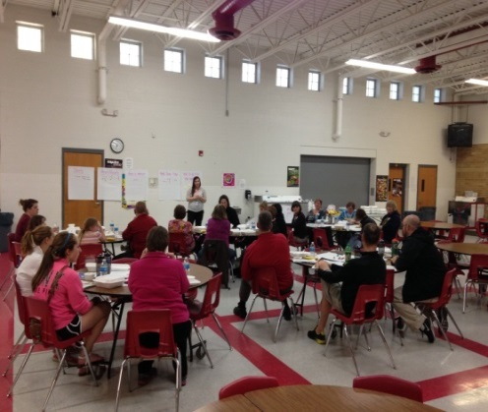

Mower Refreshed – Statewide Health Improvement Program Leadership Collaborative Team

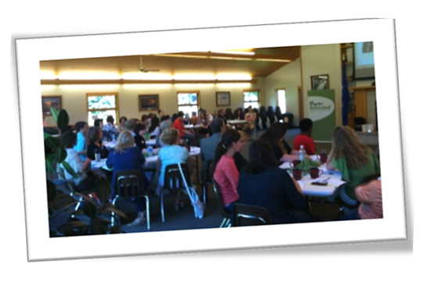
Gema Alvarado | Siebel Center
Sandy Anderson | Mower Refreshed
Diane Baker | United Way of Mower County
Amy Baskin | Austin Public Schools
Mark Christopherson | Mayo Clinic Health System
Miguel Garate | Riverland Community College
Ellen Goslee | Riverland Community College
Jill Hart | Mayo Clinic Health System
Lisa Kocer | Mower County Health & Human Services
Maryanne Law-Sunde | Parenting Resource Center
Larry Lyons | Hormel Foods, Inc.
Shawn Martin | Riverland Community College
Adrianne Noyola | U of MN Student
Tedd Maxfield | YMCA of Austin
Eric Olson | KSMQ Public TV
Scot Ramsey | Mayo Clinic Health System
Pastor Mike Sager | Faith Church
Deb Smith | Brownsdale Public Library
Karissa Studier | Mower County SHIP
Melanie Welsh | LeRoy-Ostrander Public Schools

Additional Collaborating Partners


Dr. Richard Schindler
Austin Area Chamber of Commerce
Austin Area Drug Task Force
Residents of Mower County
Mower County Schools
Vision 2020
The Welcome Center
Mower County Community Health staff
Mower County WIC participants
Minnesota Department of Health
MDH Regional Epidemiologist
MDH Regional Nurse Consultant
Dr. Joel Schieck
Steve Sallee, Leroy/Southland Public Schools


Mower County
Community Health Services

Improving the health of Mower County residents
and the communities they live in requires far more than programming, it requires a shift in culture. Creating a change in culture requires collaboration with the people in which issues are impacting. Engaging those who are directly impacted by these issues will require time and innovation but will likely increase sustainable improvement.

Creating sustainable environments, systems, and policies are key to improving the health of our county. If we work to influence the environment, it will have a direct impact on systems and policies. The journey described in this document gives insight to what the county already has in place where we live, work, play, and learn and where we need to grow.

Mower County Community Health Improvement Value Statement

Develop collaborative strategies with community partners that are solution-focused and strength-based to improve access to healthcare, community connections, and the basic needs of residents in Mower County.

Key Principles

Healthcare
Create, support, and grow affordable and timely access points for healthcare needs (home/community based services, dental, and general medical needs).
Community Connections
Create, support, and grow safe communities that foster resiliency in individuals, families, and businesses through healthy social connections that value diversity.
Basic Needs
Create, support, and grow access to healthy foods and active living opportunities.

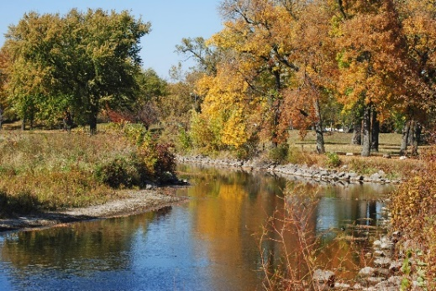
Demographics | Mower County

Mower County is located in southeastern Minnesota. Sixteen communities, with Austin being the largest, are spread over a largely agricultural setting with small river ways offering recreation and beauty throughout the county’s landscape.

The 2013 census estimated the county’s population at 39,327 with continual growth projected between 2015 and 2045. This growth has already been seen with the expansion of Austin’s kindergarten center and the construction of a new intermediate school to accommodate the expanding student population. Continued growth can also be seen in the healthcare sector as Mayo Clinic Health System-Austin has expanded their clinical setting and a large local employer has implemented a substantial worksite clinic.

Income
The median household income is $45,596 and the percent of persons in Mower County living below the poverty is approximately 14.1 percent. While 68.4 percent of the residents in the county have a high school diploma (or equivalency) or higher, poverty is still an issue with far reaching impact. Poverty has also been noted in Mower County schools with over 50 percent of enrolled students being eligible for free and reduced priced meals.

The unemployment rate in Mower County has continually been below the state average. Six industries are the main sources of employment in the county: manufacturing being the top, followed by health care, government, retail trade, educational services, lodging and food services. Sixty percent of employed Mower County residents both live and work here, while forty percent travel to neighboring counties for employment. Over five thousand people commute to Mower County for employment.

Mower County Community Health Improvement Plan embraces this as an opportunity to not only strive for the “healthiest county” but also to support health and wellness efforts in surrounding counties where Mower County residents may work, play and learn.

Diversity
The ethnic makeup of the county has under gone a significant change in the past ten years, especially in the community of Austin. Caucasian continues to be the primary ethnic group at 92.5% and the number of people self-reporting to be Hispanic or Latino is 10.4%. According to the Welcome Center in Austin, “Austin has recently seen a large influx of Asian refugees from Southeast Asia. The number of Karen and Karenni residents in Austin nearly tripled to 1,224 this year from 463 in 2012”.

*Can be another race

Mower County’s age ranges are also widely distributed with a higher than state average elderly population. The percent of elderly persons above 65 years of age in Minnesota is 13.7, Mower County is well above the state average at 17.3 percent.

Community Health Assessment Process | Top Ten Priorites

The Assessment Process

The purpose of a community health assessment provides the foundation for improving and promoting the health of the community. The community health assessment identifies factors that affect the health of a population and helps determine the availability of resources within the community to adequately address these factors. Through the assessment process, community health boards identify and describe the health status of the community; factors in the community that contribute to health challenges; and existing community assets and resources that can be mobilized to improve the health status of the community.

In early January 2013, Mower County Community Health (MCCH) worked with the Minnesota Department of Health’s Center for Health Statistics to create a customized survey that was mailed out to a random sampling of Mower County households. MCCH also invited Mayo Clinic Health System, Austin campus to collaborate on survey questions, creating a collaborative foundation for both health organizations to better understand the residents they serve. This was a significant step in developing what is now an on-going partnership to address the health priorities identified by county residents rather than a silo approach that wastes resources and misses out on collective insights.
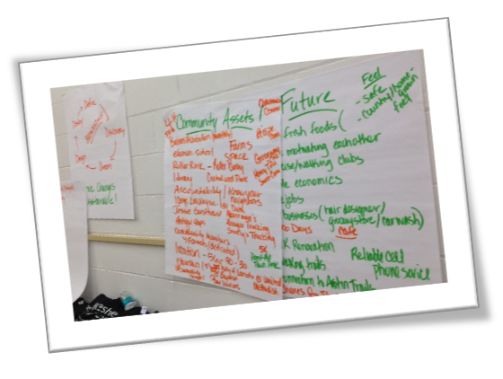
The survey process took approximately 4 months to complete. Data was analyzed by the Minnesota Department of Health (MDH) and returned to the local health department as part of its overall data collection process. Data regarding top health issues in Mower County was also collected from the following data sources: Minnesota Student Survey, Mower County Women, Infant & Children (WIC) data, Mayo Clinic Health System – Austin campus Community Health Needs Assessment, infectious disease data from the MDH Southeast (SE) regional epidemiologist, SE Minnesota Food Access Profile, Mower County Vital Statistics Trend Report – MDH, County Health Rankings, County Health tables, and Kids Count Minnesota 2012.

In order to get feedback from citizens that perhaps were not represented in the returned randomized mailed survey, focus groups were also conducted. Those focus groups included; English Language Learner adult class participants, WIC participants, Community Health staff, Mower Refreshed-Statewide Health Improvement Program Leadership Collaborative team, Mower County Community Health Services Advisory Committee, employer groups and Riverland Community College Students. Results from the returned surveys along with the focus group data were then tabulated to come up with the top 10 health priorities for Mower County.

In October 2013, the Mower County Board of Health approved the top ten health priorities identified.

Top Ten Health Priorities
The following are the top ten health issues that surfaced through the survey and focus groups, listed in no order of significance:
- Access to healthcare
- Alcohol, tobacco, and other drugs
- Child and adolescent growth and development
- Chronic/noninfectious disease
- Health disparities
- Lack of exercise and activity
- Mental Health
- Obesity among children and adults
- Poor or inadequate parenting
- Unintended pregnancy/teen pregnancy

Community-Driven Strategies & Planning | Top Three Opportunities

The Planning Process

A community Health Improvement Plan provides guidance to the health department, its partners, and its stakeholders on improving the health of the population within the health department’s jurisdiction. The plan is a guide to defining actions to target efforts that promote health.

Mower County Community Health has a close working relationship with Mayo Clinic Health System-Austin. It is through this partnership that the top ten health priorities were brought to county-wide residents to drill the top 10 identified health issues down to three. In the following narrative the process of identifying the top three as well as measures and strategies that are in place or being developed to address these needs will be described.

The next step was to engage residents in considering the top three health issues they believed were of greatest concern in their community. This process of surveying took place through focus groups in a variety of community settings including public health staff, written surveys, and a collaborative community engagement effort by Mower County Statewide Health Improvement Program and Mower Refreshed called County Conversations. There was great intention taken to go to the residents where they live, work, play, and learn, providing environments that were comfortable and felt safe. It was in these environments and through the formats listed that participants were asked to identify the top three health concerns they believed impacted their communities the most. The level of participation was not only significant in numbers of engaged residents but in the diverse age and ethnic groups represented. The conversations gave residents a chance to identify community strengths and identify health concerns in their community.

Three priorities consistently rose to the top during focus groups, surveys, and County Conversations. Participants began to explore local community initiatives/resources that were effectively impacting the health topics they listed and where there appeared to be gaps.

The three health concerns that surfaced to the top (not in any order of significance) were:

- Obesity among children and adults
- Mental Health
- Access to Healthcare

Part of our process was to switch to a strength based approach. In doing so, Mower County Community Health reframed the top three priorities to “opportunities” to improve our current health status.

Mower County’s top three health opportunities:

- Improve Nutrition and Increase Active Lifestyles
- Improving Mental Health
- Improving Access to Healthcare

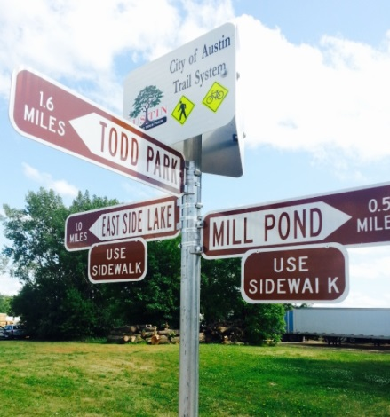
Opportunity One: Improve Nutrition and Increase Active Lifestyles

Obesity is a significant concern for residents of Mower County. The concern over both childhood and adult obesity was evident in the Community Health Assessment. Over forty percent of residents self-reported that they considered themselves overweight with over thirty percent stating they believed themselves to be obese according BMI standards. Lack of exercise was identified as a concern by almost fifty percent of participants in the assessment.

Teens who were surveyed reported that obesity amongst kids in Mower County was of high concern. “You look around school and it shows. Weight is a problem.” was a common statement from the youth. Poor eating habits, inconsistent home lives due to busy schedules, unsupervised children, and easy access to high calorie, low nutritional food at home and in social settings were mentioned frequently as influencing the rise in obesity. Stress was another significant factor related to teens and young adults that struggle with obesity. Eating as a form of coping with stress, anxiety and depression was another common theme that surfaced through the focus groups and County Conversations.


The County Conversations platform rated obesity in both children and adults as significant in the communities where conversations were hosted. Health disparities were apparent when it came to access to nutritional food and healthy food preparation. The Latinos Saludables (a wellness outreach to the Latino population through Mower Refreshed) focus group expressed the need to learn how to prepare healthy American foods as their children adapt to the American culture and desire more food commonly served in the U.S. “We understand how to make healthy Mexican food but not American so we buy boxes because it is easy.” Community members believed that families with parents working two, three or more jobs to pay bills were at a higher risk for obesity and often those needing to work multiple jobs were minorities.

Physical inactivity was at 24 percent for Mower County, while Minnesota as a state reported being 20 percent. Likewise, Mower County ranked higher in adult obesity levels at 28 percent compared with Minnesota overall at 26 percent. The 2013 Minnesota Student Survey revealed locally that 24 percent of females in 6th grade perceived themselves as being overweight. This percentage jumped to 33 percent of 12th grade females believing they were overweight. The rise of inactivity is reinforced by students reporting a decline in exercising or playing a sport that made them sweat or breathe hard for at least twenty minutes from 6th graders to 12th graders at a significant rate.

Improving Nutrition and Increasing Active Lifestyles

Measurable Objectives | Collaborative Strategies | Community Partners
- Create, support and grow initiatives that educate, equip, and empower residents with healthy strategies related to nutrition.  Process measured mid-cycle (2016) | Mower Refreshed  Refreshed Dining Initiative  Refreshed Kids School Assemblies  Harvest 5K  Latino Saludables Community Conversations | Mayo Clinic Health System (MCHS)  Mower County SHIP
 | Mower County Statewide Health Improvement Program (SHIP)  Senior gardening access  Healthy food access in food shelves  Greenhouse- Woodson Kindergarten Center  Childcare nutrition training  School nutrition  Worksite Wellness Initiatives | Mower County Senior Center | Salvation Army of Austin | Austin Public Schools | Apple Lane Child Care | Catherwood Home Child Care | Community Learning Center | Discovery Learning Center | Riverland Community College | Mower County
 | YMCA of Austin  Diabetes Prevention Program | SHIP | Mower Refreshed | Mayo Clinic Health System | Mower County Community Health | Quality Health and Wellness Clinic
 | Mower County Community Health  Women, Infants, Children | Austin Farmers Market
HyVee- Health Market
Sprouts Program
Dietician
 | Mayo Clinic Health System  Take H.O.L.D. Program | Mower Refreshed
United Way / Austin Public Schools
Backpack Program
Austin Public Schools
Free breakfast for all students
Dietician on staff
 | Community Education
 | U of M Extension  4-H  Cooking Matters programming  I CAN Prevent Diabetes Programming | Mower County SHIP | YMCA of Austin
 | Farmer’s Markets | Austin Farmer’s Market
- Create, support, and grow initiatives that educate, equip, and empower residents with healthy strategies related to active lifestyles.  Process measured mid-cycle (2016) | Mower Refreshed  Refreshed Kids School Assemblies  Harvest 5K  Latino Saludables Community Conversations  Get Moving Mower | Mower Refreshed | Mayo Clinic Health System  SHIP Mower County
 | SHIP  Childcare active living training  Worksite wellness initiatives  Active Schools | Austin Public Schools | Apple Lane Child Care | Catherwood Home Child Care | Community Learning Center | Discovery Learning Center | Riverland Community College | Mower County
 | YMCA of Austin  Diabetes Prevention Program  Physical Activity Opportunities  $1 memberships for youth | Mower County SHIP | Mower Refreshed | Mower County Community Health | Quality Health and Wellness Clinic | Mayo Clinic Health System
 | Park and Recreation
 | Vision 2020  Safe Routes to School  Bike Trails  Waterways Recreation  Recreation Center | Mower County SHIP | Austin Public Schools | City of Austin | Austin Park and Recreation
 | Mower County Senior Center
 | Lake Louise State Park
 | Mower County Senior Center
 | Mayo Clinic Health System  Take H.O.L.D. Program | Mower Refreshed
 | J.C. Hormel Nature Center


Opportunity Two: Improving Mental Health

Mental health issues do not seem to be impacted as significantly by health disparities in Mower County as the previous priority of obesity. Residents report high prevalence of stress, anxiety, and depression in all economic, ethnic, and age categories. 46.7 percent rated depression as a concern for adults and 45.4 percent rated depression as a concern for adolescents in the 2013 Community Health Assessment. The 2013 Minnesota Student Survey tells the story that depression and anxiety communicated through self-harm and thoughts of suicide are significant concerns for not only Austin Public Schools but other county districts. According to state data, Mower County residents report having 3.7 poor mental health days, while the State of Minnesota statistic is at 2.6 (County Health Rankings 2014).

According to the 2013 Minnesota Student Survey 40% of female 11th graders reported feeling very trapped, lonely, sad, blue, depressed or hopeless about the future. In that same survey 10% of the male 11th graders reported that they have thought about ending their life/committing suicide during the past year.

The focus groups and 2013 Community Needs Assessment – Mayo Clinic Health System- Austin campus, revealed mental health issues as top concerns as well. Financial concerns, relationship stressors, and undocumented status, from our Latino community members, were top stressors affecting mental health. The County Conversations also listed stress and depression as significant in their communities, impacting health and sense of safety. Unfortunately, like other rural counties, mental health services are more difficult to access.

Improving Mental Health in Mower County

Measurable Objectives | Collaborative Strategies | Community Partners
- Create, support, and grow initiatives that educate, equip, and empower residents with healthy strategies to improve mental health.  Process measured mid-cycle (2016) | Mower Refreshed  TAKE 5 Annual events/postcard campaign  Resilience Video Project  Latinos Saludables Community Conversations  Refreshed Lunch & Learns  Cooperative Health Action Triad (CHAT)  Refreshed Kids School Assemblies | Mayo Clinic Health System (MCHS) | Austin Public Schools
 | Community Against Bullying (CAB) | Austin Public Schools | Faith Communities
Mower County Health and Human Services
Family Facilitator Program
Family Home Visiting – Public Health
Austin High School
REACH Program
 | Mower County Family Collaborative  Mental Health Professional | Mower County School Districts | Mower County Health and Human Services
 | Catholic Charities
 | Parenting Resource Center
- Increase mental health awareness.  Process measured mid-cycle (2016) | Mower Refreshed  TAKE 5 Annual events/postcard campaign  Resilience Video Project  Latinos Saludables Community Conversations  Refreshed Lunch & Learns  Cooperative Health Action Triad (CHAT)  Refreshed Kids School Assemblies | Mayo Clinic Health System | Austin Public Schools
 | Depression Awareness Wellness Network | Austin Public Schools
 | Minnesota Student Survey Participation | County school districts | Mower County Community Health
 | Mental Health Awareness Walk | The Bridge | Local Adult Rehabilitative Mental Health Services
 | Adverse Childhood Experiences Research Outreach Conversations | Mower Refreshed | MCHS

Opportunity Three: Improving Access to Healthcare

Accessing healthcare has become increasingly complicated. Understanding how to connect with the appropriate level of care needed along with how to pay for the care received has been identified as a significant concern for residents from all ethnic groups, especially new immigrants to the Mower County area. Language barriers, cultural differences, and lack of health insurance leave these residents especially vulnerable to health complications because of these added barriers.

According to the 2014 County Health Rankings, Mower County’s ratio of primary care providers to patient was 1874:1. The mental health provider ratio was at 1406:1 compared to Minnesota’s ratio at 748:1. “The wait to be seen for a medical appointment makes going to Urgent Care my best option at times”, one resident stated. Access to dental care is a statewide problem, but in Mower County it is especially problematic as the ratio of dental providers to patient is 2222:1 compared to Minnesota’s ratio at 1602:1.

Though increasing actual providers requires a long term commitment both financially and in system expansion, the strategies to address this top priority are grounded in increasing understanding and collaborative partnerships to improve access. Innovative strategies have begun to take shape in Mower County.

Improving Access to Healthcare

Measurable Objectives | Collaborative Strategy | Community Partners
- Create, support, and grow collaborative strategies to increase access points to healthcare (dental, medical, mental health, immunizations, etc.)  Process measured mid-cycle (2016) | Mower Refreshed  Accessing healthcare tool | Mayo Clinic Health System (MCHS)
 | Mayo Clinic Health System  Healthspots  Nurse line  Patient Portal | Austin Public Schools
 | Children’s Dental Health Services | Mower County Health and Human Services | Mower County Schools
 | United Way 2-1-1
 | Community health workers program development | SHIP | Mower Refreshed | MCHS | Austin Public Schools | The Welcome Center | Area Faith Communities
 | County Conversations | SHIP Mower County | Mower Refreshed | Mayo Clinic Health System (MCHS)
 | Sterling Smart Clinic
 | Quick Care
 | Mower County dental providers
 | Quality Health and Wellness Clinic | Quality Pork Processors | Medcor
 | Pharmacies in Mower County
 | Health Plans (Blue Cross Blue Shield, Medica, Health Partners, UCare, etc)

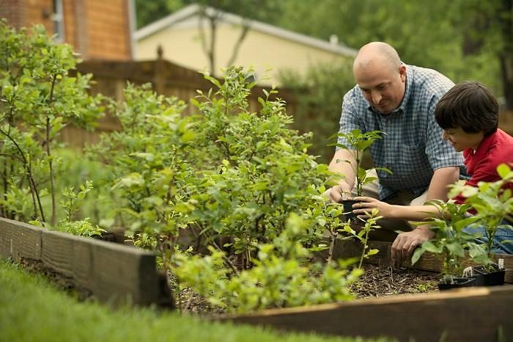



Mower County Health and Human Services
P.O. Box 537
201 First Street NE
Austin, MN 55912
507.437.9701
Mower County Website

Protecting and Promoting Community Health, Self-Sufficiency and Well-Being through Prevention Efforts, Early Intervention and Provision of Services.

